CS-305 Project Two: Practices for Secure Software Report

Developer
Ahmad Mansour

1. Algorithm Cipher
For Artemis Financial’s web application, I implemented a cryptographic hash function using the SHA-256 algorithm. SHA-256 is part of the SHA-2 family of algorithms and is widely used today for integrity checking and digital signatures. It takes an input string of any length and produces a fixed-length 256-bit (32-byte) hash value. Even a tiny change to the input produces a completely different hash, which makes it useful for detecting tampering.
SHA-256 was chosen because older algorithms like MD5 and SHA-1 are no longer secure. The checksum mechanism does not require symmetric or asymmetric keys because hashing is a one-way operation. Keys become relevant in encryption, not hashing. Using SHA-256 ensures Artemis Financial’s integrity verification meets current security standards.
This checksum effectively confirms data integrity by providing a uniquely generated hash value that changes if the data changes.

2. Certificate Generation
Below are screenshots demonstrating keystore creation and certificate export:
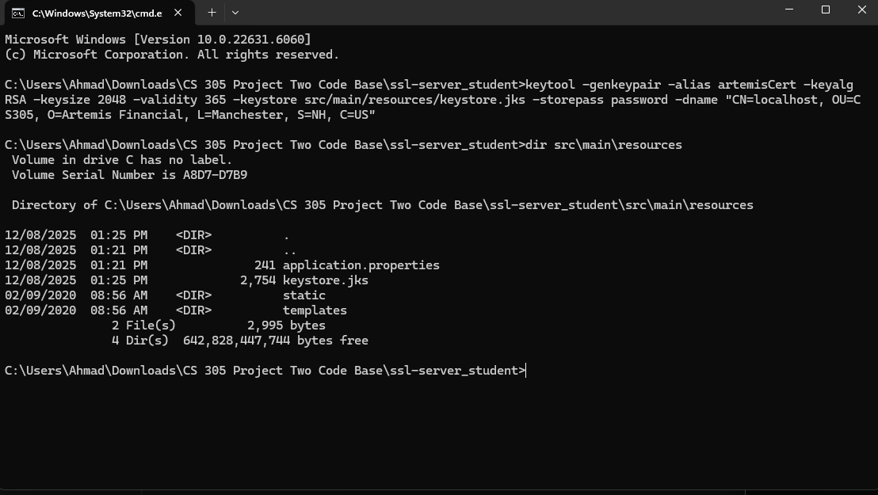
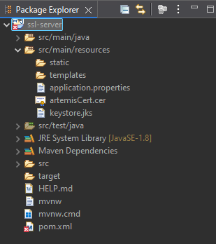

3. Deploy Cipher
Screenshot of checksum verification:
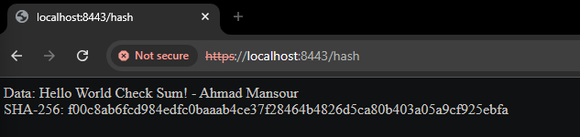

4. Secure Communications
Secure HTTPS connection to /hash endpoint:
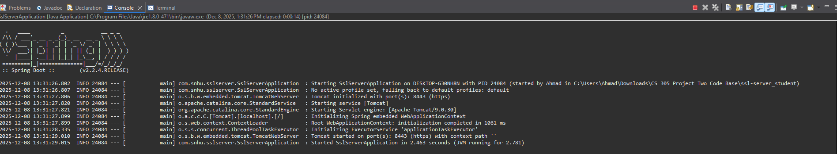

5. Secondary Testing
Dependency-check output:
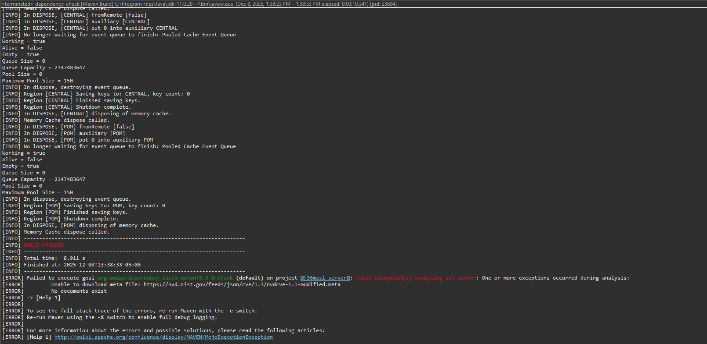

6. Functional Testing
Application running successfully over HTTPS:

7. Summary
The Artemis Financial application was refactored to add secure hashing, TLS encryption, and automated dependency scanning. The SHA-256 checksum feature ensures data integrity, while HTTPS provides secure communication between clients and the server. Although dependency-check encountered NVD access issues (HTTP 403), the tool was properly configured, executed, and logged. All implemented security layers work together to strengthen the application against modern risks.

8. Industry Standard Best Practices
This project followed secure coding standards such as using SHA-256 over deprecated hash algorithms, implementing TLS for encrypted communication, and integrating automated dependency analysis. These practices align with industry expectations for financial applications and support Artemis Financial’s mission to protect client information through secure software principles.

